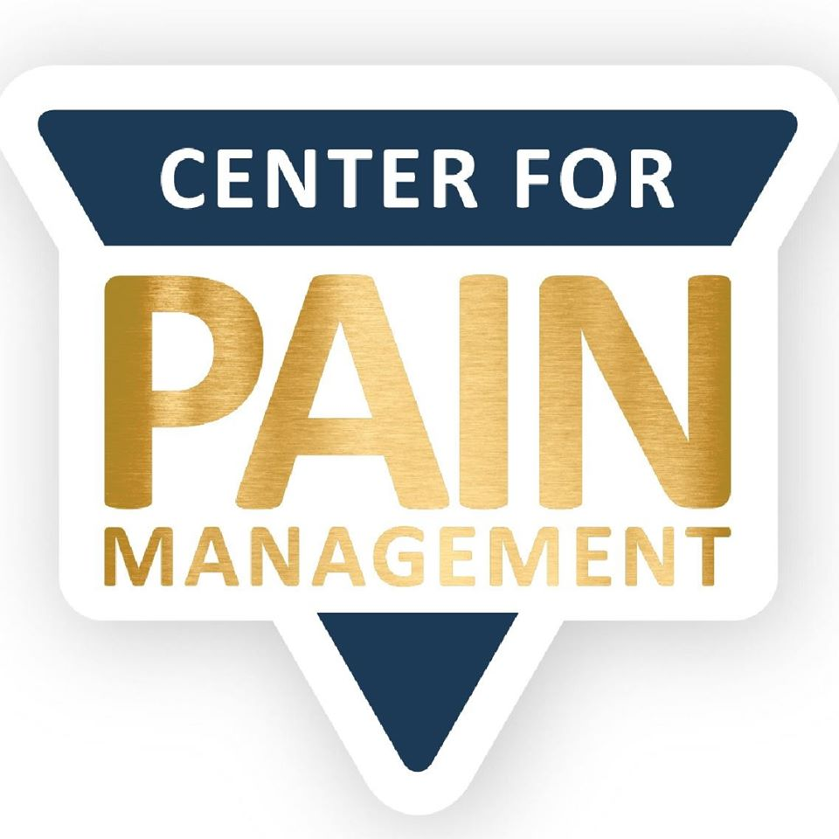
EVANSVILLE

Phone: 317-706-7246
Fax: 317-706-3417
4411 Washington Ave Ste 100
Evansville, IN 47714
ROCKPORT

Phone: 317-706-7246
Fax: 317-706-3417
107 N. 2nd Street
Rockport, IN 47635
JASPER

Phone: 317-706-7246
Fax: 317-706-3417
3559 N. Newton Street
Jasper, IN 47546

www.IndyPain.com
PATIENT REFERRAL

Please fax/mail this form along with recent office notes, medication list,
all diagnostic reports, front and back of insurance card(s), and insurance referral.
Workers’ Compensation (√ if applicable) Motor Vehicle Accident

DATE:
PATIENT INFORMATION
Name: DOB:
Address: Home #:
City/State/Zip: Work #:
Insurance Carrier: Mobile #:
Diagnosis:

REFERRING PHYSICIAN
Name: Practice:
Address: Phone #:
City/State/Zip: Fax #:
NPI #__________________________________________ Office Contact:______________________
REQUEST:

EVANSVILLE JASPER ROCKPORT
First Available __________ First Available __________ First Available __________
Or request: ____________ Or request: ____________ Or request: ____________

Physicians are Board Certified by the American Board of Anesthesiology (ABA) with added qualifications in Pain Management

