TELEMEDICINE VISIT
APP FROM PHONE OR TABLET:
- Install APP from App store: VSee Clinic for Patient App
(green box with white C)
- MAY see “Vsee Clinic” would like to send you notifications- Select Allow
- At this point, no further action is needed until the day of your appointment.
- On the day of your appointment, you will receive a text around your appointment time stating, “You have been invited to a secure video visit…” Click on blue “https:/curogram-0022.vsee……..” link.
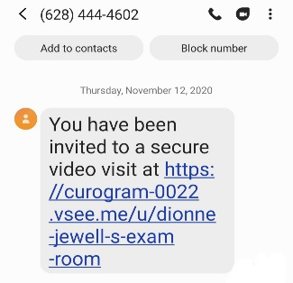

- New Page- Click green OPEN box in top right corner

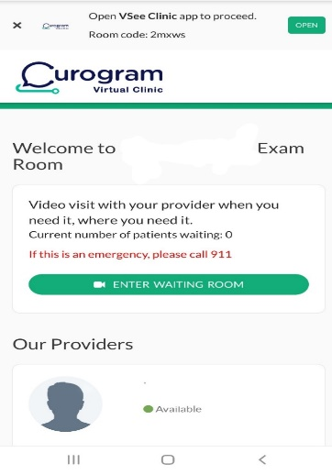
- New page- Click green “Enter Waiting Room”
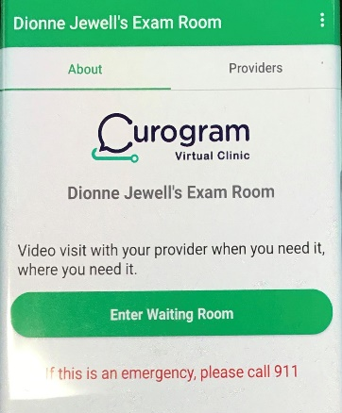

- New Page- Enter your Name and Date of Birth and click box stating, “I give my consent to participate in this telemedicine consultation.” Then click green “Enter Waiting Room”.
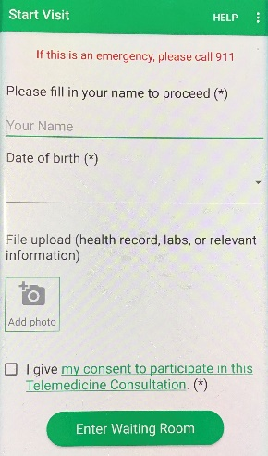

our text here

- New Page- (iphone) VSee clinic would like to access the camera. Select OK
(android) Allow Vsee Clinic to take pictures and record video? Select allow
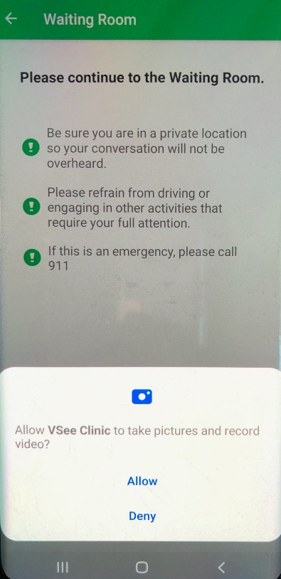

- New Page- (iphone) Vsee Cllinic would like to access the mircrophone. Select OK
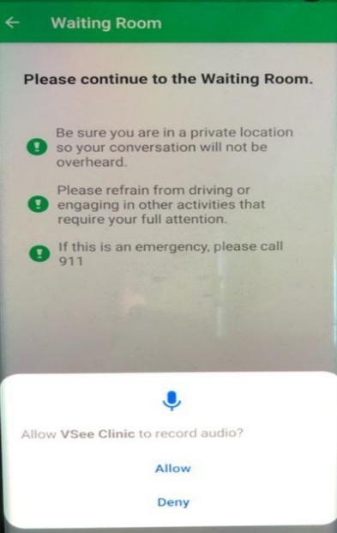
(android) Allow Vsee clinic to record audio? Select Allow

10. Final page- “Your provider will be with you shortly. Thank you for waiting….” 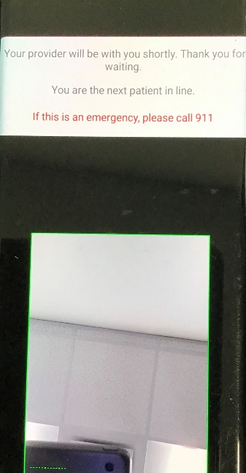 ***A medical assistant will be with you shortly. If you are having issues

connecting, a medical assistant will contact you by phone to assist with the process. Thank you!

